Question 2:

* Find the envelope of EMG signal using Hilbert transform
* Rectify the envelop

CODE:

Envelop detection without Hilbert transform:

clc;

clear all;

load('SADAT_EMG_I_L01.mat');

s = data;

Fs = 500;

t = linspace(0, 1, length(s))/Fs;

[yup,ylo] = envelope(s,25,'peak');

figure(1)

plot(t, s)

hold on

plot(t, yup, 'r', 'LineWidth',1)

plot(t, ylo, 'r', 'LineWidth',1)

hold off

grid

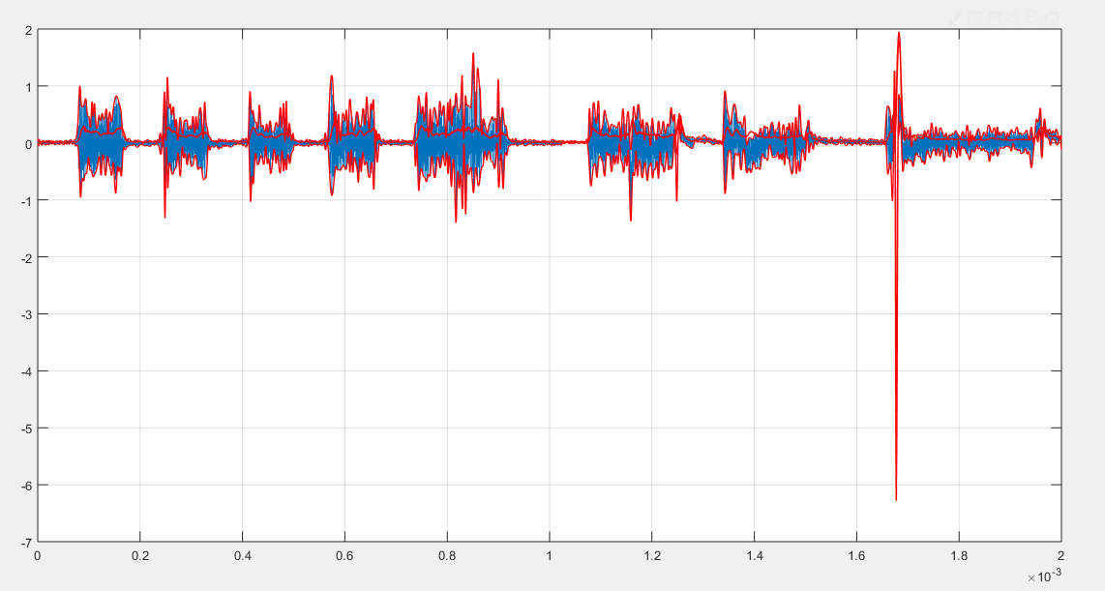Figure 1.9: Envelope detection of EMG signal

Using Hilbert transform:

CODE:

clc;

clear all;

load('SADAT_EMG_I_L01.mat');

signal=data;

Fs=500;

envelope(signal,Fs);

analy=hilbert(signal);

y_abs=abs(analy);

figure();

N=2*2048;T=N/Fs;

sig_f=abs(fft(y_abs(1:N)',N));

sig_n=sig_f/(norm(sig_f));

freq_s=(0:N-1)/T;

plot(freq_s(2:250),sig_n(2:250), 'r', 'LineWidth',1);

title('Envelope Detection : Hilbert Transform')

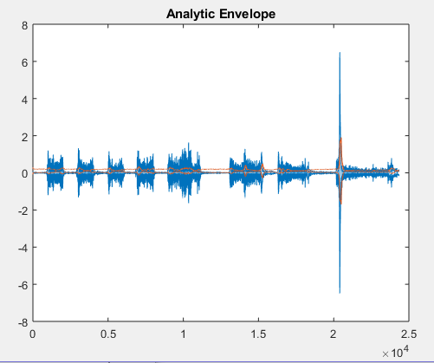

Figure 1.10: Envelope detection of EMG signal (Analytic Envelop)

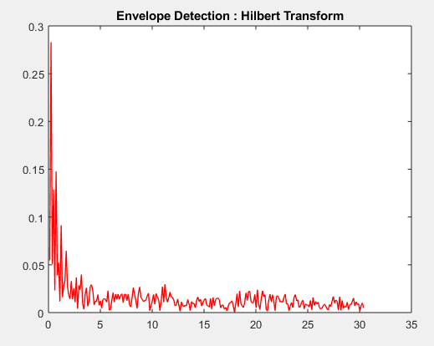

Figure 1.11: Envelope detection of EMG signal ,using Hilbert transform